Nurses, Matrons, Laundresses & Cooks
Women of the Civil War

Presented by

Angela Y. Walton-Raji
aywaltonraji@gmail.com

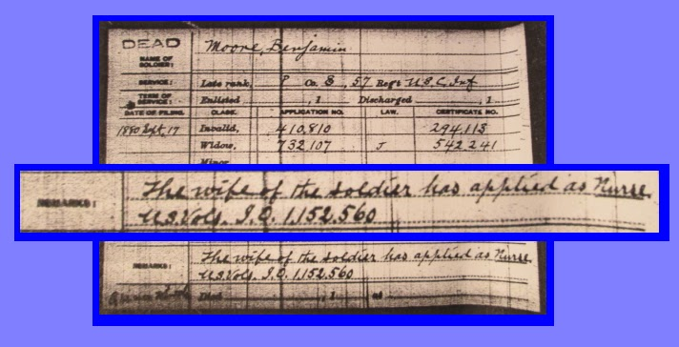

Several thousand women served in the capacity of nurses and matrons during the Civil War, although the exact numbers are not known. Through carded service records, one can find the names of 20,000 women served the Union Army, but they served in multiple categories, as nurses, matrons, laundresses and cooks. These nurses came from all classes and backgrounds. Among these women were women who were white, women of color, some of whom were newly freed slaves, and contrabands.
They served in some camp sites, but many served in hospitals established as conditions warranted them. This workshop will look at the roll of the Civil War Women and the roles they played in various hospitals, campsites and medical units in the Civil War.

- Positions and Skills: Matrons, Nurses, Laundresses, Cooks
- Matrons – Administrative Tasks and Overseers to Medical Care often in hospitals
- Nurses – Like Matrons, their tasks were often administrative. Skills in tending wounds were required
- Laundresses and Cooks – Often short termed in time serving in various hospitals

- Status and Class of Women
- Color and race were a factor in assigned tasks.
- Literacy was a factor for many nurses and matrons, and often separated them from other workers

- Blurred Lines Regarding Duties and Tasks
- Often those who had the menial tasks of cooking and cleaning, frequently found themselves working with patients, cleaning wounds and more.
- Assigned tasks often determined by place of employment. Large hospital such as Philadelphia or Richmond hired women differently than small specialized units such as a Contraband Smallpox hospital.
- After major battles when large numbers of wounded arrived nurses and matrons also found themselves working alongside laundresses and other workers performing other “domestic” duties.

- Racial dynamics of medical workers
  - Women of color often assigned domestic tasks
  - Dismissive treatment towards black nurses and matrons
  - Washer women given nurses tasks.

- The Civil War Pension Process
- Numbers who applied and received pensions
- Eligibility requirements
- Proving one’s service

- Finding and locating data of Civil War women workers
- Record Group 94
- Contract Nurses Ledgers
- Black Nurses and the records reflecting them.

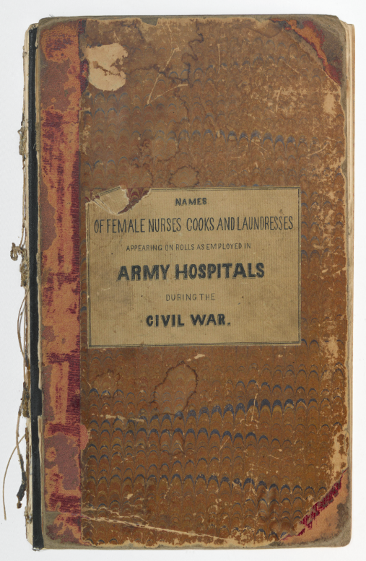
Ledger of Women who served as Nurses, Laundresses & Cooks at
US Army Hospitals in the Civil War.

Ledgers of Contract Nurses (not digitized) can be found at the National Archives in Washington DC. A meeting with the military archivist will assist the researcher in examining the ledgers.
After the Civil War, the National Association of Army Nurses of the Civil War was formed, that lasted for many years. The Grand Army of the Republic invited former nurses to participate in one of their major encampments for the year 1900. Information about this association is found among the Mary Ann Bickerdyke papers, which can be found on the Library of Congress website.
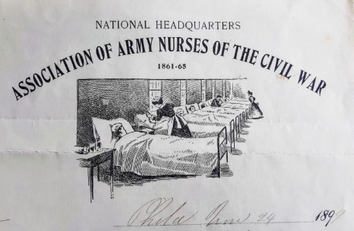

Additional Information:

-Mary E. Roberts Anderson, The Story of Aunt Lizzie Aiken, Janse, McClurg 1880
-Sophronia E. Bucklin, In Hospital and Camp, John E. Potter, 1869;
-Jane Hoge, The Boys in Blue, or, Heroes of the “Rank and File” 1867
-Mary A. Livermore, My Story of the War.The Civil War Memoirs of the Famous Nurse, Relief Organizer and Suffragette
-Mary Elizabeth Massey, Women in the Civil War Univ. of Nebraska Press, 1966
-Mary A. Newcomb,Four Years of Personal Reminiscences of the War, H.S. Mills, 1893
-Stephen B. Oates, Woman of Valor. Clara Barton and the Civil War, The Free Press 1995
-National Archives & Records Administration. Record Group 94 Entry 535
-Susie King Taylor, Reminiscences of My Life in Camp with the 33d United States Colored Troops, Late 1st S.C. 1902

Internet Resources:

“Angels of the Battlefield”
http://www.civilwarhome.com/civilwarnurses.htm

“Remembering Black Nurses in the Civil War, USCTChronicle.blogspot.com”
http://usctchronicle.blogspot.com/2012/07/colored-contract-nurses-in-civil-war.html

“Following Footsteps of Black Civil War Nurses”
http://usctchronicle.blogspot.com/2013/04/following-footsteps-of-black-civil-war.html

“The Civil War and Nursing”
http://topics.nurse.com/civilwar

